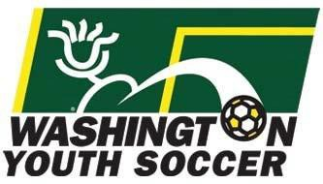
2019 STATE TRYOUT DATES – all leagues and level of play
2018-19 State Cup Dates
December 8-9, 2018 | Recreational Cup |  | Semifinals/Finals
February 2-3, 2019 | Founders Cup |  | Semifinals/Finals
February 8-10, 2019 | 15U-18U State Championships & Presidents Cup |  | Semifinals/Finals
April 26-28, 2019 | 9U-11U Presidents Cup |  | Semifinals/Finals
May 3-5, 2019 | 12U-14U State Championships & Presidents Cup |  | Semifinals/Finals
May 10-12, 2019 | 15U-18U State Championships & Presidents Cup |  | Semifinals/Finals
2018-19 Regional/National Dates
June 11-16, 2019 | US Youth Soccer West Presidents Cup |  | Norco, CA
June 17-23, 2019 | US Youth Soccer Far West Regional Championships |  | Boise, ID
July 10-14, 2019 | US Youth Soccer National Presidents Cup |  | TBD
July 23-28, 2019 | US Youth Soccer National Championships |  | Overland Park, KS
2019 Tryout Dates for 2019-20 Season
-ALL LEAGUES and LEVELS OF PLAY-
Birth Year | Upcoming Season | First Possible Day of Tryouts
 | 2019-20 | Boys | Girls
11 | 9U | April 24-25 | April 24-25
10, 09, 08 | 10U, 11U, 12U | May 1-2 | May 1-2
07, 06, 05 | 13U, 14U, 15U | May 8-9 | May 8-9
04, 03, 02, 01 | 16U, 17U, 18U, 20U | February 12-13 | May 15-16

